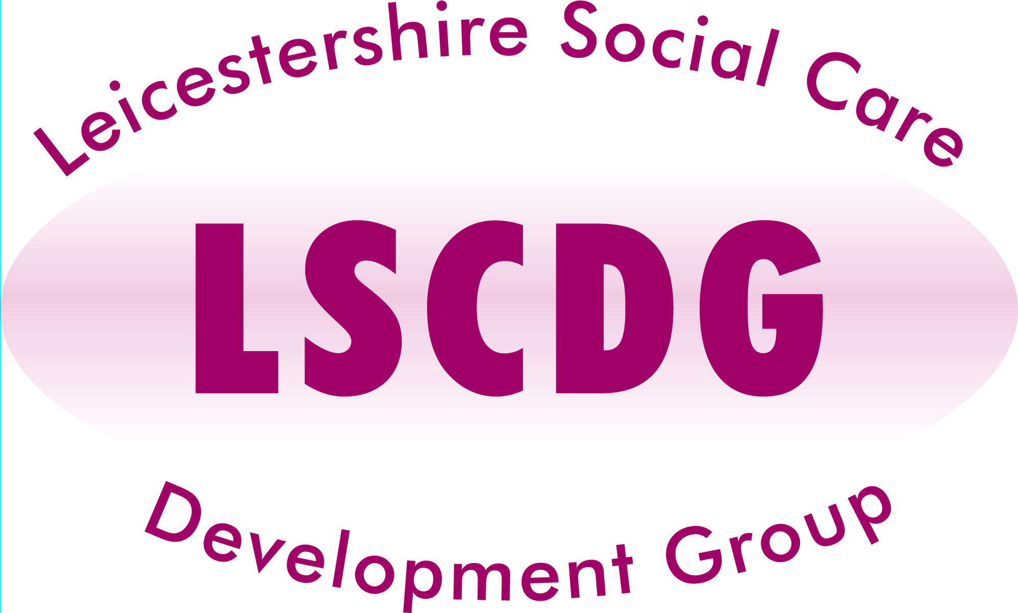
Mental Capacity Act 2005 (MCA) Assessments for Managers

(Half day Training - £15 per delegate)

THIS TRAINING IS NOT REVELANT FOR LOCAL AUTHORITY STAFF.

Aims and objectives include:
- To become more familiar with how the MCA empowers people to live the type of lives they wish to live.
- To understand how to support people to understand the decisions we ask them to make (Principle Two)
- To explore how we undertake capacity assessments.
- To review some written capacity assessments – what makes an assessment ‘good enough’; what makes it lacking?
- To reflect on how to bring this back into their work setting.

Target Group:
Managers or Senior Staff that are responsible for quality monitoring the implementation of the MCA with their service users.

Dates | Venues
Tuesday 11 November 2014 | Peepul Centre, Leicester
Wednesday 10 December 2014 | Salvation Army, South Wigston
Wednesday 4 February 2015 | Gorse Covert Community Centre, Loughborough
Monday 2 March 2015 | Snibston Discovery Park, Coalville

Times: Refreshments at 9.00 for a 9.15 Start to finish 12.45

Refreshments provided, however lunch will not be provided. Employers will be responsible for travel costs.

With effect from April 2014, LSCDG will be implementing changes in the business process, for the forthcoming training programme for 2014 - 2015.

For this course care providers will be invoiced at a flat rate of £15 delegate, after the attendance.

If delegates fail to attend, the establishment will be invoiced for the non-attendance rate of £50.

VISIT OUR NEW WEBSITE - www.Lscdg.org

Click on the ‘Training Events’ tab, scroll down to choose the Course and Date you wish to attend.

From here you will be able to check availability and book yourself on the training.

